**Topics: Normal distribution, Functions of Random Variables**

1. The time required for servicing transmissions is normally distributed with *μ* = 45 minutes and *σ* = 8 minutes. The service manager plans to have work begin on the transmission of a customer’s car 10 minutes after the car is dropped off and the customer is told that the car will be ready within 1 hour from drop-off. What is the probability that the service manager cannot meet his commitment?
2. 0.3875
3. 0.2676
4. 0.5
5. 0.6987



**Answer: B. 0.2676**

1. The current age (in years) of 400 clerical employees at an insurance claims processing center is normally distributed with mean *μ* = 38 and Standard deviation *σ* =6. For each statement below, please specify True/False. If false, briefly explain why.
2. More employees at the processing center are older than 44 than between 38 and 44.

**Answer: True.**

**Probability of employees having age more than 44 is more than between 38 and 44.**

1. A training program for employees under the age of 30 at the center would be expected to attract about 36 employees.

**Answer: True.**

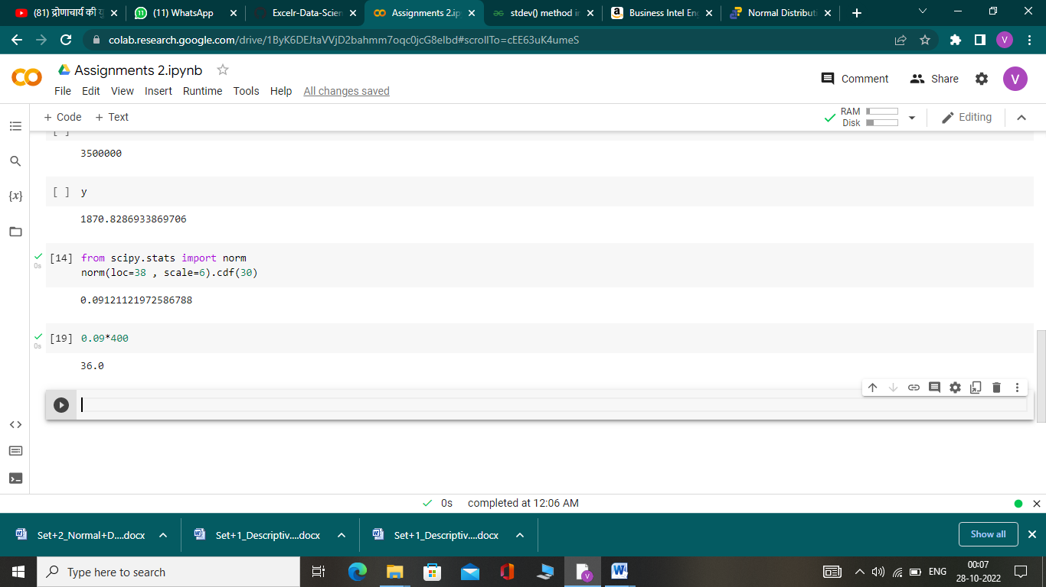

1. If *X1* ~ *N*(μ, σ2) and *X*2 ~ *N*(μ, σ2) are *iid* normal random variables, then what is the difference between 2 *X*1 and *X*1 + *X*2? Discuss both their distributions and parameters.

**Answer: Difference between 2X1 and X1+X2 =**

**2X1=N(2μ , 4σᴧ2)**

**X1+X2=N(μ+μ ,σᴧ2+,σᴧ2)N(2μ , 2σᴧ2)**

**2X1-(X1+X2)= N(4μ , 6σᴧ2)**

**The difference between these two variable implies that they are identically and independently distributed.**

1. Let X ~ N(100, 202). Find two values, *a* and *b*, symmetric about the mean, such that the probability of the random variable taking a value between them is 0.99.
2. 90.5, 105.9
3. 80.2, 119.8
4. 22, 78
5. 48.5, 151.5
6. 90.1, 109.9

**Answer: D.48.5, 151.5**

1. Consider a company that has two different divisions. The annual profits from the two divisions are independent and have distributions Profit1 ~ N(5, 32) and Profit2 ~ N(7, 42) respectively. Both the profits are in $ Million. Answer the following questions about the total profit of the company in Rupees. Assume that $1 = Rs. 45
2. Specify a Rupee range (centered on the mean) such that it contains 95% probability for the annual profit of the company.

**Answer: qnorm(0.025,45*5,3)=219.12**

**qnorm(0.975,45*5,3)=230.87**

**qnorm(0.025,45*7,3)=309.12**

**qnorm(0.975,45*7,3)=320.87**

**The rupee range for Profit1=( 219.12,230.87)**

**The rupee range for Profit2=( 309.12,320.87)**

1. Specify the 5th percentile of profit (in Rupees) for the company

**Answer: qnorm(0.05,45*5,3)=220.0654**

**qnorm(0.05,45*7,3)=310.0654**

**5th percentile of profit =530.1308**

1. Which of the two divisions has a larger probability of making a loss in a given year?

**Answer: 2nd division has larger probability.**